Project Wet Incredible Journey

Travel in the Water Cycle

**Board Game –**

1. Each player is given a chip as a playing piece.

2. Place all playing pieces on “Spring.” Roll die to determine which player goes first.

3. Roll die and move marker to the location indicated by the die.

4. Record moves on the game sheet by drawing lines.

5. The game continues until one player has visited all 9 places or time is called by the teacher. [Lake, Glacier, Animal, River, Plant, Soil, Groundwater, Ocean and Cloud]

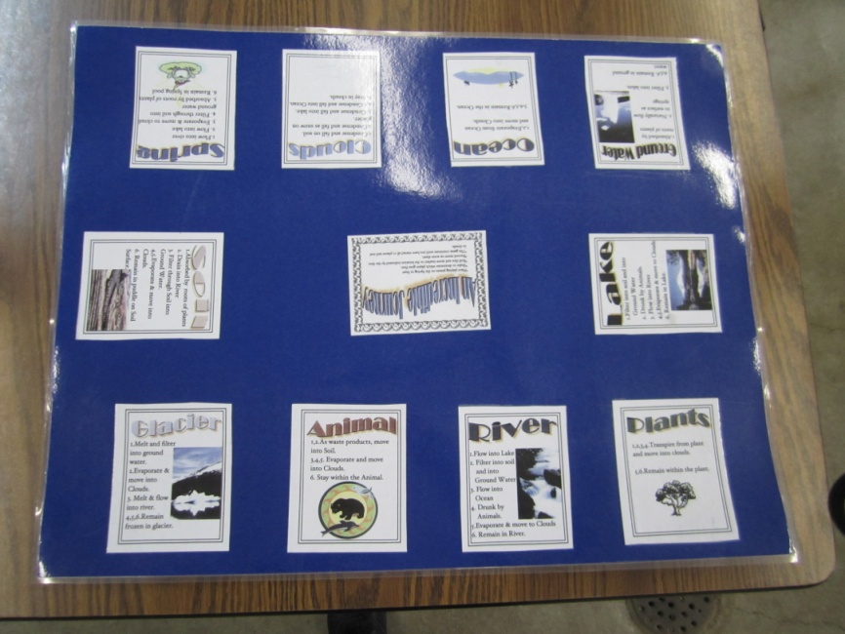

10 ‘place settings’ around the edge

Player instructions in the center